Implications of Ground Based and Satellite Derived Measurements on Techno-Economic Evaluation of Photovoltaic Grid Connected System in Kajang, Malaysia
Banupriya Balasubramanian¹, Azrul Mohd Ariffin², Kuan Tze Mei²
Keywords: Solar radiation, photovoltaic grid connected system (PVGCS), Satellite derived data, Ground based measurement, Malaysia, Databases.
This research work specifically deals with the examination of utilizing the solar irradiance data from different sources such as land based, National Aeronautics and Space Administration/Surface meteorology and Solar Energy (NASA/SSE), renewable energy technologies screen (RetScreen) simulation software, hybrid optimization model for electric renewables (HOMER), in assessing the financial practicability and feasibility of solar photovoltaic grid connected system (PVGCS) situated at Kajang, Malaysia. The financial implications of using free solar radiation databases which is available to the public versus accurate ground measured data in designing the solar photovoltaic grid connected system had been investigated. Financial studies mainly focused on the different key economic criterions such as net present value (NPV), payback period (PBP) and discounted payback period (DPP). Investigations conducted in Kajang had revealed that satellite based software tools over-predicts the daily average solar irradiation, which in turn provides inaccurate information to the investors and so leads to possibility of financial losses.

1. introduction
Availability of reliable solar radiation data is vital for assessing, designing and developing solar photovoltaic based projects. These solar radiation data can be defined for a location by several ways. Among that, the global horizontal irradiation (GHI), the amount of terrestrial radiation received from a surface horizontal to the ground is commonly of most interest to the developers. Specifically, the yearly long term average of GHI is preferred. Solar energy maps, satellite derived data and land-based measurement are the main sources of solar radiation data. Though all of these sources have its’ own merit but the selection depends on the specific location. Solar resource data from other sources such as satellite measurements or meteorological stations can be calibrated using the ground based measurement in a specific location for the purpose of improving the accuracy and certainty [1].
Typically satellite data or renewable energy technologies screen (RetScreen) simulation software or hybrid optimization model for electric renewables (HOMER) have been utilized by researchers to determine the technical practicability and financial assessment of a solar PV system [2–7]. Both RetScreen and HOMER utilize the data obtained from the NASA or other meteorological centers based on historical solar radiation measurements recorded within a certain period of time. Thus it can be argued that the assessment conducted by these software could be misleading to some extent, as they do not consider the actual data collected at present time. Moreover these data are obtained through satellite network at the nearest airport to the location of interest instead of its exact point of location. Therefore, techno-economic viability of solar photovoltaic grid connected systems situated at Kajang, Malaysia, was assessed by making use of the different radiation databases such as free solar irradiance data versus accurate ground measured data in order to find the implications on the cost-benefit analysis.
2. Significance of the Study
Precisely predicting the hourly, monthly and yearly solar irradiation data is essential for the investors especially on large-scale solar PV projects in order to determine the economic feasibility at a particular location for the installation of a solar photovoltaic system [8]. Method and the choice of data provider for determining the solar radiation data in W/m² for a specific geographical site is a critical determinant for the purpose of designing the solar PV system with the desired level of accuracy. Over prediction or under prediction of solar radiation data in a specific location strongly influences the financial portion of the project as the real world conditions may differ substantially to the data set used in the modeling of the solar PV system design [9].
3. Data Sources
3.1 Ground Based Solar Radiation Data
A full year’s worth of every 15 minute’s logged solar irradiation (G) and ambient temperature (T_{a}) data was provided by the installed experimental solar tracking system of 3.15 kWp capacity situated at BN building rooftop, College of Engineering (COE), Universiti Tenaga Nasional (UNITEN), Kajang, Malaysia. This grid connected solar monitoring system is used for research purposes by academics at the university in the field of renewable energy and is therefore viewed as a credible source of accurate solar irradiation ground data. The collected data of G and T_{a} was then downloaded in the “comma-separated-values” (.csv) file format to the laptop for simulating the energy generation by the developed simulation tool in Kajang. Complete system schematic has been shown in Fig. 1. The PV system comprises of forty-two 75 Wp Siemens SP mono-crystalline modules configured in a 6 parallel by 7 series string combination installed.
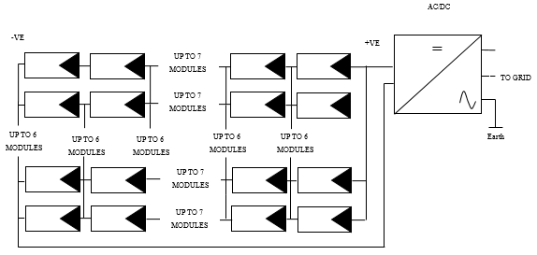
Fig. 1 – Solar PV rooftop system’s overall schematic diagram.
Nevertheless, most of the solar modeling software programs such as RetScreen, HOMER, etc., require the average daily available energy per m² or kWh/m²/day at a specific latitude and longitude for each month of the year. Usually the solar irradiation components – direct normal irradiation (DNI), diffuse horizontal irradiation (DHI) and global solar irradiance (GHI) – are measured as instantaneous power measurements per meter squared or W/m². GHI data is the required solar irradiation component for photovoltaic applications. The raw data of solar radiation needs to be converted into kWh/m²/day [9].
3.1.1. Developed Simulation Tool
An equivalent circuit based simulation tool has been developed in Microsoft Visual Studio (.Net) platform for predicting the solar power output by incorporating the effect of various types of photovoltaic modules based on the environmental parameters of G and T_{a}. For simplicity, the single-diode model is studied in this research. The .net simulation tool is equipped with a database of innumerable types of solar panels with dissimilar electrical characteristics for computation purposes. The maximum power output was evaluated against the manufacturer’s claimed output at standard test conditions (STC), with cell temperature of 25ºC and solar irradiance of 1000 W/m² in order to assess the simulation accuracy. Also the simulated results were compared and validated with the field-measured data acquired from a couple of systems installed in UNITEN. The two solar PV systems are 3.15 kWp solar PV rooftop system and 17.28 kWp solar PV carport system. Good agreements had been found between the simulated results and the field measured data.
3.2 Satellite Derived Data
3.2.1. NASA SSE
Free satellite data has been provided by the NASA SSE database for users online merely for all locations around the world. Nevertheless, the free database is only available from the year 1983-2005. For this research purpose, in order to determine the average daily solar irradiation for every month of the year (kWh/m²/day), 22 years averaged data for the coordinates of Kajang site was included; since UNITEN is situated at Kajang. Latitude and longitude for the desired geographical location is the only required input for data and the solar irradiation component (i.e.: GHI component for modelling solar PV). Typically, 100 km by 100 km square is the resolution of the data [9].
Kajang site is located at the following coordinates:
Latitude - 2.9931° N
Longitude - 101.7889° E
3.2.2. RetScreen
Meteorological data required in the model is included in the RetScreen climate database. User would be able to obtain the climate data from ground monitoring stations and/or from NASA’s global satellite/analysis records by executing the software. The data will be provided from NASA’s satellite/analysis records if the climate data is not available from a specific ground monitoring station. Next to the data in the climate database dialogue box (Fig. 2 (a)), the source of the data (i.e., “Ground” or “NASA”) is indicated [10].
3.2.3. HOMER
Typically the solar resource data set in HOMER is input as global solar radiation on the horizontal surface (GHI). Both the direct normal and diffuse radiations are included. It is expressed in kWh/m². Based on the latitude and longitude provided and clicking the “Get Data via Internet” button as shown in Fig. 2 (b), HOMER accesses its online database that serves up data from either National Renewable Energy Laboratory’s (NREL) Climatological Solar Radiation (CSR), or NASA’s Surface meteorology and Solar Energy (SSE) data set. Preferably, CSR dataset is used since it has finer surface resolution though it only provides data for about 25 % of the earth. SSE data is used if the CSR data is not available [11].

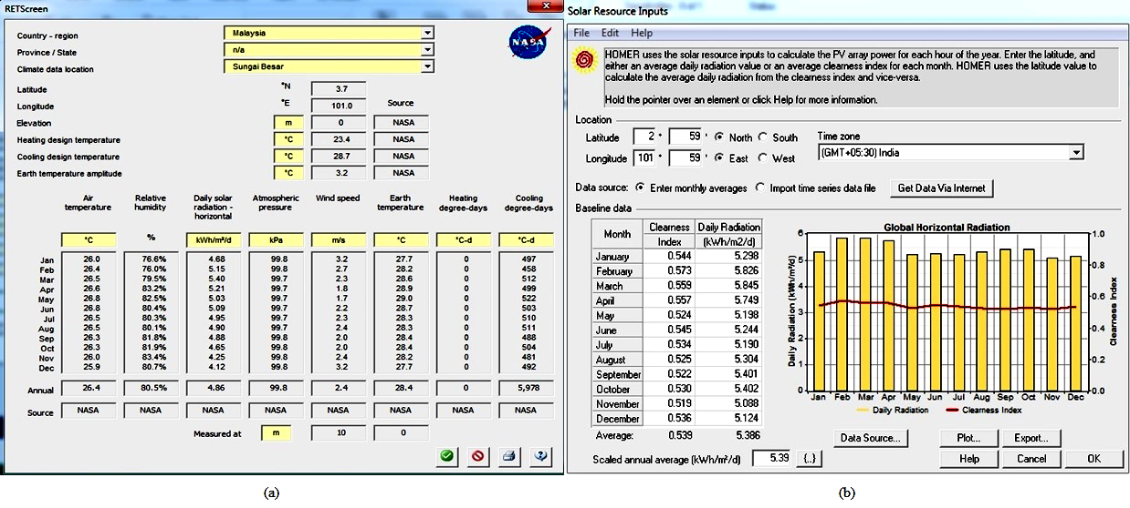Fig. 2 – Climate database dialogue box (a) RetScreen and (b) HOMER [10, 11].
4. Analysis and Discussions
Accurate solar radiation data for the specific site is essential when designing a solar energy system in order for determining the economic indicators of NPV, PBP and DPP precisely based on the available amount of energy. Hence, as a first step, free solar radiation databases of NASA SSE, RetScreen and HOMER were compared with the ground measured radiation data (G) using the statistical measures of mean bias error (MBE) and the root mean square error (RMSE) for the Kajang site. Then, fiscal analysis was carried out by using the annual energy generation by the developed simulation tool (ground based) versus satellite derived data for the system capacities of 18 kWp, 60 kWp, 450 kWp, 6.75 MWp and 22.5 MWp inclusive of the UNITEN BN building rooftop 3.15 kWp solar photovoltaic grid connected system in Kajang, with the consideration of three typical module technologies of Siemens SP 75Wp mono-crystalline, 75Wp Solo Power thin film and Trina Solar 225 Wp polycrystalline.
The averaged deviation between satellite and ground measured solar irradiation data is indicated by the MBE and the value can be positive or negative. The formula for MBE is given by the following equation [12]:
$\text{MBE}=\frac{\sum_{i=1}^{N}{I_{S\left(t\right)}−I_{g\left(t\right)}}}{N}$, (1)
where N is the number of measurements, I_{s(t)} is the satellite or predicted (modelled) values and I_{g(t)} is the ground measured values.
The RMSE shows the deviation of the predicted to the measured values and is always positive. RMSE can be calculated using the following equation [13]:

$\text{RMSE}=\sqrt{\frac{\sum_{i=1}^{N}{{\left(I_{S\left(t\right)}−I_{g\left(t\right)}\right)}^{2}}}{N}}$. (2)
4.1 Comparison of Different Solar Radiation Databases with the Ground Data
Table 1 shows the summary of the data sets from different solar radiation databases for Kajang site, which is used for the comparison and cost-benefit analysis. For the purpose of this research work, the ground monitored data of BN building rooftop at UNITEN is viewed to be the main source for solar radiation data due to the fact that it measures the actual solar radiation at ground level of Kajang.
Table 1
Yearly solar irradiance data for Kajang (2012)
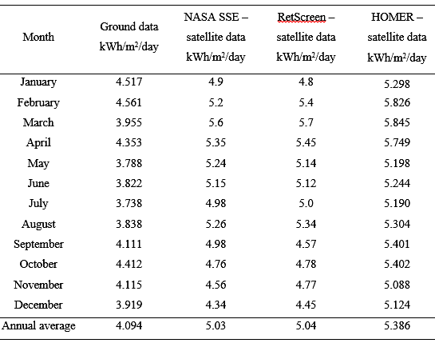
4.1.1 Statistic Measures Used
The ground-measured data was compared with the satellite-derived data using the statistical measures of MBE and RMSE. Both the differences between measured and modelled values (using RMSE), and the existence of systematic over or underestimation tendencies (using MBE) can be determined [13]. Table 2 represents the MBE and RMSE between the ground measured and satellite derived solar radiation data for Kajang site.
From Table 2, it can be seen that MBE is positive so the satellite data recorded by the NASA SSE, RetScreen and HOMER over predicts the solar irradiance that was actually measured at ground level and also responsible for solar PV output. This is further supported by the RMSE value, indicating that the overestimation is quite substantial for HOMER followed by the RetScreen and NASA SSE. Hence, it can be expected that the solar energy estimated using these satellite databases would be more than the actual one recorded at ground level.
Table 2
MBE and RMSE for different data sets
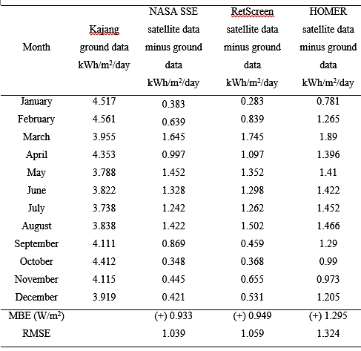
4.2. Comparison of kWh Produced by the Developed and Free Software Tools
The actual energy delivered to the grid (E_{dlvd}) harvested per year by the BN rooftop 3.15 kWp solar system was then simulated for Kajang as the reference site for different module technologies namely mono-crystalline, thin film and polycrystalline. Different data sets have been taken for each month which typically stored as a .CSV file with an interval of 15 minutes for each solar radiation and ambient temperature parameters. Those data sets measured for each month at solar PV energy system installed in UNITEN was then fed into the developed simulation tool in order to find the energy generated specifically in Kajang using different module types and system sizes.
The energy delivered to the grid per year produced by the freely available software tools can be determined using the annual average solar radiation, G (Table 1) by Eq. (3) and the results are shown in Table 3 [15-17]:
$E_{\text{dlvd}}=\frac{\left(S´\text{Ins}´\text{365}\right)}{\text{1000}}$, (3)
where S is the system size and Ins is the annual average insolation at site. Table 3 clearly indicates that the NASA SSE, RetScreen and HOMER over predict the energy generation compared to the actual one. But in real time scenario, the actual energy generation in the Kajang site for the mono-crystalline module should be decreased by 28.15 %, 28.30 % and 32.90 % and for the thin film module should be decreased by 28.76 %, 28.90 % and 33.46 % respectively when utilizing the NASA SSE, RetScreen and HOMER satellite data.
Similarly the actual energy generation for the poly crystalline module should be decreased by 28.83 %, 28.97 % and 33.53 % correspondingly when utilizing the NASA SSE, RetScreen and HOMER satellite data in order to attain the best fit.
Table 3
Annual electricity production by different software tools
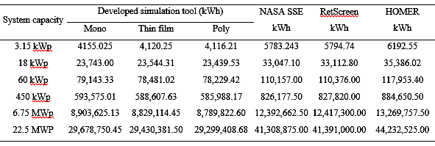
There are several reasons that may have contributed to this variation. Firstly, the solar irradiance, which is the main parameter responsible for energy generation, is different for the satellite data obtained via NASA SSE, RetScreen, HOMER and the ground measurement recorded by the solar PV system. Since the ground measurement of the solar irradiance is the one directly affects the generation of a solar PV system, it can be said that the forecast of energy generation based on actual solar irradiance measurement is more accurate than the prediction using the satellite data. As highlighted in Table 3, the difference in the energy forecast between these four mechanisms can be as high as around 33 %, depending on the type of PV technology used for the analysis.
Secondly, Eq. (3) only takes into consideration of the solar PV system size and not the type of module used for the system. For the same system size however, the type of module will have minimal effect in the solar energy generation as long as the module efficiency remains almost similar. Comparing the energy generation using the actual solar irradiance measurement for different module types as outlined in Table 3, the variation between them was calculated to be around 1 % only. This further suggests that the difference between the energy predicted using the ground and satellite measurement is mainly due to the solar irradiance data itself, and not so much on the type of PV module defined for the system.
4.3. Comparison of Economic Indicators by the Developed and Free Software Tools
Utilizing the energy generated from the free software tools and actual simulated software model, NPV, PBP and DPP were calculated for the base case economic assumptions as shown in Table 4. PV electricity tariff or failures in time (FIT) rate varies with the installed capacity [18].
Table 4
3.15 kWp PVGCS economic assumptions
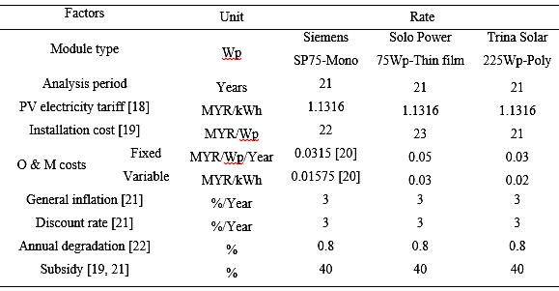
4.3.1. Net Present Value (NPV)
Net present worth (NPW) or net present value (NPV) or discounted cash flow is originating with an initial investment, S and discounting sum of all the positive or negative cash flows that are produced in the future years, j of duration of the investment, N. Here the future cash flows are indicated as Q₁ for the first year, Q₂ for the second year, Q_{N} for the N-th year. The cash flows must be updated in making this comparison, by referring each one to the year in which it shall be available and multiplying it by the relevant discount factor [23]. Consequently as per the definition of net present value (NPV), Eq. (4) represents the difference between the initial investments; S and the sum of the N discounted cash flows (with N as the duration of the investment).
$\begin{aligned}\text{NPV}\text{=-}S+\frac{Q_{1}}{\left(1+i\right)}+\frac{Q_{2}}{{\left(1+i\right)}^{2}}+\text{.}\text{.}\text{.}\frac{Q_{N}}{{\left(1+i\right)}^{N}}= \\ \text{=-}S+\sum_{j=1}^{N}{\frac{Q_{j}}{{\left(1+i\right)}^{j}}},\end{aligned}$ (4)
where S is PV system cost, Q_{j} is cash flow in the year j, i is nominal interest rate and N is life time of solar PV system (in years). If the NPV results in a positive number then it indicates that discounted cash flows produced will have greater returns than the initial investment cost at the end of life of the investment. Subsequently from the financial point of view, the development of a plant is favourable, and vice versa when the NPV is negative [23].
Table 5
NPV (MYR) result for different software tools
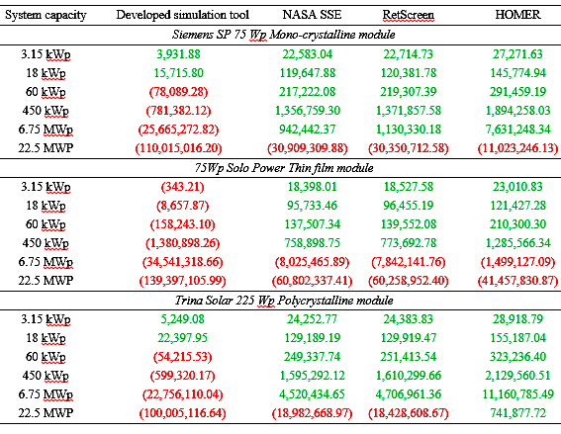
Table 5 represent the NPV values calculated based on the annual solar energy estimated using the satellite data of NASA SSE, RetScreen, HOMER and the developed simulation tool respectively. From the figure, it can be generally concluded that NPV becomes more negative as the solar PV system size increases due to higher investment risk. Out of 18 test case studies conducted for four methods, around 77.78 % showed positive NPV estimated using satellite data of NASA SSE/RetScreen and 83.3 % using HOMER as opposed to only 22.2 % using the ground data measurement (Fig. 2). This suggests that even though the difference in the energy estimation using the NASA SSE/RetScreen, HOMER and the developed simulation tool can be merely around 28 % and 33 % (Table 3) respectively, the difference in terms of NPV estimation could be significantly higher.
4.3.2. Simple Payback Period (PBP)
In order to measure the financial attractiveness of a project, the easiest and most basic measure is PBP. The period of time required for a project’s cumulative revenues to return its investment through the annual (non-discounted) cash flow is known as the payback period. Any project with a shorter payback period is the most attractive kind of investment [24]. PBP can be calculated as:
$\text{PBP}=N+\frac{\text{UC}}{\text{CF}}$, (5)
where N is the number of years prior to full recovery of investment, UC is unrecovered cost at start of year and CF is cash flow during full recovery year. PBP for each case was determined using Eq. (5) for the four methods and the results are shown in Table 6. Since the fiscal analysis period was set to 21 years, payback period beyond 21 years (denoted by ‘∞’) would not be deemed as favourable from the energy producer’s point of view. As expected, PBP increases with increasing system capacity. PBP computed using the satellite data shows that 100 % of the test case studies have less than 21 years for their solar PV projects to breakeven. This percentage however, decreases dramatically to around 61 % if the computation of PBP was made based on the energy estimated using the developed simulation tool. Similar to the NPV analysis, the stark difference in PBP using the four methods for energy generation computation may possibly give wrong estimation in terms of the number of years to recover the initial investment for a solar PV system.
Table 6
PBP (years) result for different software tools
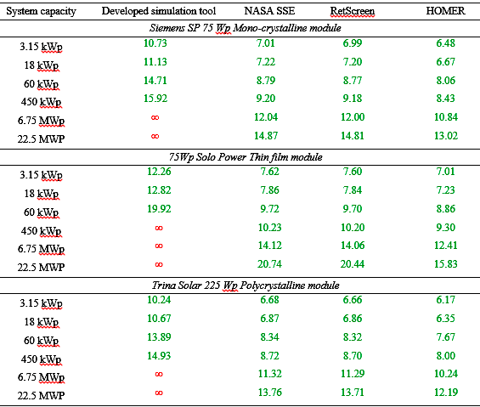
4.3.3. Discounted Payback Period (DPP)
While accounting for the time value of money, it is the number of years required for recovering the project cost of an investment. DPP is particularly useful for quickly assessing the duration during which an investor’s capital is at risk [24]. DPP is calculated simply as:
$\text{DPP}=Y+\frac{\text{CCF}}{\text{DCF}}$, (6)
where Y is the year before DPP occurs, CCF is the cumulative cash flow in year before recovery and DCF is discounted cash flow in year after recovery. DPP is a slightly different method to assess the number of years to breakeven the cost of a solar PV project as compared to PBP, in the sense that DPP takes into consideration the discounted value for cash flow year by year. Similar to PBP, computation was performed for all 18 test cases using the energy estimated by free software tools of NASA SSE, RetScreen, HOMER and also the developed simulation tool, as tabulated by Table 7. Around 77.78 % and 83.3 % out of the test cases showed ‘favorable’ number of years to recoup the initial investment for solar PV systems using the energy estimated by NASA SSE/RetScreen and HOMER, as opposed to only 22.2 % for the energy based on the developed simulation tool. Even though the percentages are very different compared to those obtained for PBP, it is interesting to note that they are consistent with the percentages obtained in the NPV calculation. This suggests that DPP would probably be the better option in determining the payback period of a solar PV project investment.
Table 7
DPP (years) result for different software tools
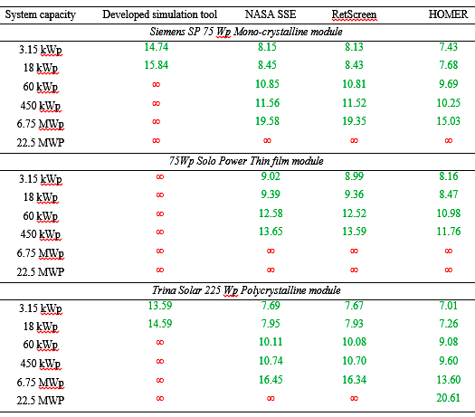
5. Conclusions
Accurate solar radiation data for the specific site is essential when designing a solar energy system in order for determining the economic indicators of NPV, PBP and DPP precisely based on the available amount of energy. For the purpose of this research paper, the ground monitored data of BN roof top, UNITEN was viewed to be the most accurate solar irradiation data to determine the financial implications due to the fact that it is measuring the actual solar irradiation experienced at ground level of Kajang site, Malaysia.
The economic analysis of photovoltaic grid tied systems in Kajang had been carried out using the free solar radiation databases which is available to the public versus accurate ground measured data. From the results and discussions, it was evident that for the Kajang location, satellite based software tools have been seen on average over predicts the available daily solar irradiation. Satellite based solar irradiation data used to calculate the financial indicators, overestimate the net present value and under estimate the payback time required to recuperate the investment when compared to the ground monitored system.
It is therefore plausible to suggest that by using the satellite based data set which over estimates the amount of solar irradiation available at a specific location will ultimately end up in a risk or impact of incorrect decisions by the investors based on the highest NPV and lower pay back period and as well wrong system design such as reduced number of PV arrays, etc.
Accuracy of the satellite based long term averaged solar irradiation data can be improved by incorporating an additional input, for instance a kind of variability metric which relies on ground based measurements, may help the investors not to wind up with wrong conclusions.
ACKNOWLEDGMENTs
The authors would like to acknowledge the financial assistance of Ministry of Higher Education (MOHE), Malaysia under the ERGS scheme for providing scholarships for this study.
Received on February18, 2019
references
- ∴ Utility Scale Solar Power Plants: A Guide For Developers and Investors. International Finance Corporation (IFC) website. http://www1.ifc.org/ (2012).
- A. H. Mirzahosseini, T. Taheri, Environmental, technical and financial feasibility study of solar power plants by RETScreen, according to the targeting of energy subsidies in Iran, Renewable and Sustainable Energy Reviews, 16, 5, pp. 2806-2811 (2012).
- A. Sumper, M. Robledo-Garcia, R. Villafafila-Robles, J. Bergas-Jane, J. Andres-Peiro, Life-cycle assessment of a photovoltaic system in Catalonia (Spain), Renewable and Sustainable Energy Reviews, 15, 8, pp. 3888-3896 (2011).
- E. F. Bazen, M. A. Brown, Feasibility of solar technology (photovoltaic) adoption: A case study on Tennessee's poultry industry, Renewable Energy, 34, 3, pp. 748-754 (2009).
- L. Ayompe, A. Duffy, S. McCormack, M. Conlon, Projected costs of a grid-connected domestic PV system under different scenarios in Ireland, using measured data from a trial installation, Energy Policy, 38, 7, pp. 3731-3743 (2010).
- M. Kashif-Shahzad, A. Zahid, T. ur-Rashid, M. A. Rehan, M. Ali, A. Mueen, Techno-economic feasibility analysis of a solar-biomass off grid system for the electrification of remote rural areas in Pakistan using HOMER software, Renewable Energy. 106, pp. 264-273 (2017).
- Z. Li, F. Boyle, A. Reynolds, Domestic application of solar PV systems in Ireland: The reality of their economic viability, Energy. 36, 10, pp. 5865-5876 (2011).
- J. Munoz, O. Perpinan, A simple model for the prediction of yearly energy yields for grid-connected PV systems starting from monthly meteorological data, Renewable Energy, 97, pp. 680-688 (2016).
- J. Dekker, M. Nthontho, S. Chowdhury, S. P. Chowdhury, Investigating the effects of solar modelling using different solar irradiation data sets and sources within South Africa, Solar Energy, 86, 9, pp. 2354-2365 (2012).
- ∴ Natural Resources Canada. RETScreen Software Suite. http://www.retscreen.net/ang/home.php (2016), Accessed 22 Nov. 2016.
- ∴ HOMER Energy. Energy Modeling Software for Hybrid Renewable Energy Systems. http://homerenergy.com/index.html Accessed 13 Dec. 2017.
- D. Yang, Kriging for NSRDB PSM version 3 satellite-derived solar irradiance, Solar Energy, 171, 1, pp. 876-883 (2018).
- T. Kato, Prediction of photovoltaic power generation output and network operation in Integration of Distributed Energy Resources in Power Systems, pp. 77-108, http://dx.doi.org/10.1016/B978-0-12-803212-1.00004-0 (2016).
- I. Moradi, R. Mueller, B. Alijani, G. A. Kamali, Evaluation of the Heliosat-II method using daily irradiation data for four stations in Iran, Solar Energy, 83, 2, pp. 150-156 (2009).
- ∴ Fundamentals of Photovoltaics. MIT Open Course Ware Lecture Notes. http://ocw.mit.edu/courses/mechanical-engineering/2-626-fundamentals-of-photovoltaics-fall-2008/lecture-notes/lecture1.pdf (2008).
- G. W. Massey, Essentials of Distributed Generation Systems, Jones & Bartlett Publishers (2010).
- G. M. Masters. Renewable and Efficient Electric Power Systems, John Wiley & Sons (2004).
- ∴ FiT Dash Board. Sustainable Energy Development Authority Malaysia, http://seda.gov.my/ (2013), Accessed 10 January 2014.
- I. Felea, V. Moldovan, D. Albut, Specificities in analysis of energy availability generated by photovoltaic sources, Rev. Roum. Sci. Techn.– Électrotechn. et Énerg., 61, 1, pp. 42-47 (2016).
- ∴ MBIPV Project. http://www.mbipv.net.my (2017). Accessed 08 March 2017.
- M. Q. Duongi., N. T. N. Tran.; G. N. Sava, V. Tanasiev, Design, performance and economic efficiency analysis of the photovoltaic rooftop system, Rev. Roum. Sci. Techn.– Électrotechn. et Énerg., 64, 3, pp. 229-234 (2019).
- ∴ Afghanistan Clean Energy Program. Kandahar City Utility Interconnected 10 MWp Photovoltaic Power System Feasibility Assessment, United States Agency International Development (USAID) http://pdf.usaid.gov/pdf_docs/PNADY059.pdf (2010).
- ∴ Technical Application Papers, 10, Photovoltaic plants. ABB library, http://www.abb.com (2014).
- M. N. Akter, M. A. Mahmud, M. T. O. Amanullah, Comprehensive economic evaluations of a residential building with solar photovoltaic and battery energy storage systems: An Australian case study, Energy and Buildings, 138, 1, pp. 332-346 (2017).

